Module Code: COS1512

Assessment: Assignment 4

Student Number: 69234175

Name: Jaymeen Patel

Unique Number: 170516

Due Date: 19/09/2022

Question 1

a)

b) The purpose of a base case is to end a recursive function and not let it run infinitely.

c) The general case is where the recursive function is called.

d) The base case is, if (counter == 0)

e) The general case is, count(--counter);

f) #include <iostream>

using namespace std;

void count(int counter)

{

if (counter == -1)

return;

else

{

cout << counter << endl;

count(--counter);

return;

}

}

int main()

{

int i = 3;

count(i);

return 0;

}

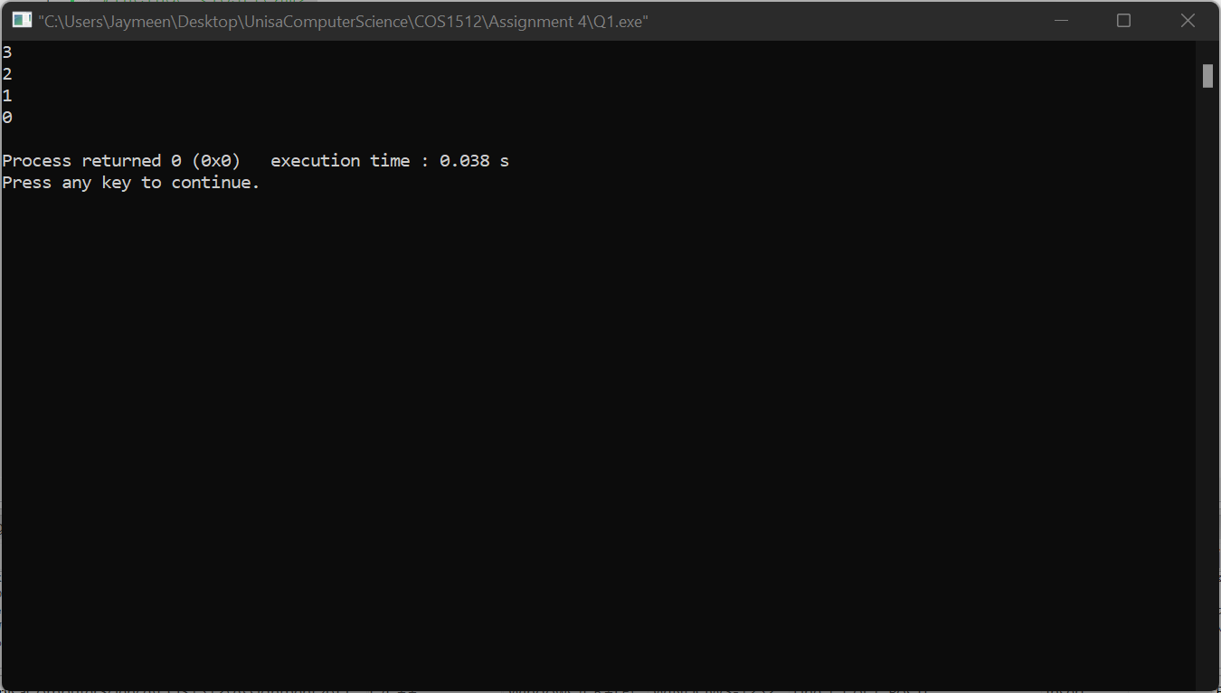

Question 2

a) Line 18 is not a valid access because the getter/accessor is protected and not public.

b) Line 32 is a valid statement because the object for function A is declared correctly.

c) Line 42, 42: int a = objA.getX();

d) Class C private variables : none

protected variables : int getx();

int z

public variables : void setx();

int getZ();

void setZ();

e) Class C private variables : none

protected variables : int getx();

int z

void setx();

public variables :

int getZ();

void setZ();

Question 3

#include <iostream>

#include<string>

using namespace std;

class Marks

{

public:

Marks();

Marks (string name, string number, int asg1, int asg2, int asg3, double test);

double calcMark() const;

string getName() const;

string getNumber() const;

double getassignmentMarks()const;

private:

string stdtName;

string stdNumber;

int assignments [3];

double testMark;

};

Marks::Marks()

{

stdtName = "Eric";

stdNumber = "654653176 ";

assignments[0] = 67;

assignments[1] = 74;

assignments[2] = 60;

testMark = 77;

}

Marks::Marks(string name, string number, int asg1, int asg2, int asg3, double test)

{

stdtName = name;

stdNumber = number;

assignments[0] = asg1;

assignments[1] = asg2;

assignments[2] = asg3;

testMark = test;

}

double Marks::calcMark() const

{

return testMark;

}

string Marks::getName() const

{

return stdtName;

}

string Marks::getNumber() const

{

return stdNumber;

}

double Marks:: getassignmentMarks() const

{

return(assignments[0] + assignments[1] + assignments[2]);

}

////

////

class FinalMark : public Marks

{

double eMark;

public:

FinalMark(): Marks{}

{

eMark = 78;

}

FinalMark(string name, string number, int asg1, int asg2,

int asg3, double test, double exMark) : Marks{name, number, asg1, asg2, asg3, test}

{

eMark = exMark;

}

int calcMark() const

{

double asgMarks, test, fmark;

test = Marks::calcMark();

asgMarks = (Marks::getassignmentMarks())/3.0;

fmark = test*0.2 + asgMarks*0.1 + eMark*0.7;

return int(fmark);

}

};

int main()

{

Marks marks;

cout<< marks.getName() << ", " << marks.getNumber() << "has got "<<marks.calcMark() << " marks " << endl;

FinalMark myMark;

cout<<myMark.getName() <<", "<< myMark.getNumber()<<"has final mark of "<<myMark.calcMark() << " marks " << endl;

return 0;

}

f) The statement would be invalid because testMarks is not a public variable so only derived classes can access it.

Question 4

#include <iostream>

#include <vector>

#include <string>

using namespace std;

template<class T>

int count(vector<T> v1, T val)

{

int j = 0;

for ( int i = 0; i < v1.size(); i++)

{

if(val == v1[i])

j++;

}

return j;

}

int main()

{

vector<int> v1;

vector<char> v2;

char calpha, cval;

int inum, ival;

cout << "Enter a list of numbers and end with number 0 " << endl;

cin >> inum;

while (inum!=0)

{

v1.push_back(inum);

cout << "Enter next number: " << endl;

cin >> inum;

}

cout << "Enter number to search for: " << endl;

cin >> ival;

cout << ival << " occurs " << count<int>(v1, ival) << " times" << endl;

//

//

cout << "Enter alphabet letters and end with character # " << endl;

cin >> calpha;

calpha = tolower(calpha);

while (calpha!='#')

{

v2.push_back(calpha);

cout << "Enter next alphabet letter: " << endl;

cin >> calpha;

calpha = tolower(calpha);

}

cout << "Enter alphabet to search for: " << endl;

cin >> cval;

cval = tolower(cval);

cout << cval << " occurs " << count<char>(v2,cval) << " times" << endl;

return 0;

}

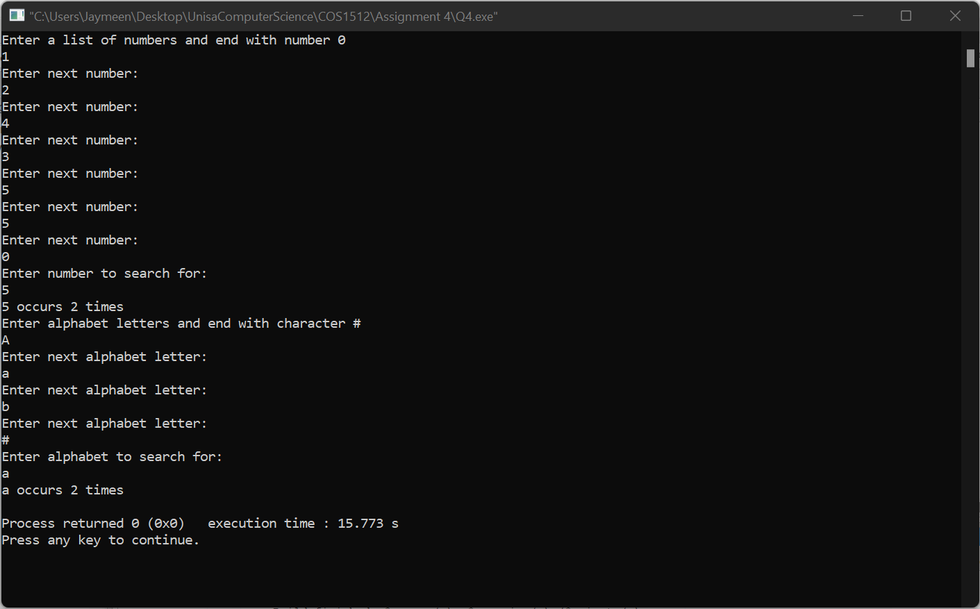

Question 5

Main.cpp

//#include "Dictionary.cpp"

#include <iostream>

#include <cstdlib>

#include "Dictionary.h"

#include <vector>

#include <string>

using namespace std;

int main()

{

Dictionary <int,string> parts();

string part;

int key;

//add 4 values to the parts dictionary

for (int i = 0; i <= 3; i++)

{

cout << "Please enter a part name and a key to add to the parts dictionary." << endl;

cout << "Part name: ";

getline(cin, part);

cout << "Key for part name: ";

cin >> key;

parts.add(key, part);

//cin.get();

}

cout << endl;

parts.display();

cout << endl;

//find the part for a key

cout << "For which key do you want to find the part? ";

cin >> key;

cout << "The part for key " << key << " is ";

cout << parts.find(key) << endl;

// cout << parts.find(100002);

return 0;

}

Dictionary.cpp

#include "Dictionary.h"

#include <vector>

#include <iostream>

#include <cstdlib>

using namespace std;

template<class Tkeys, class Tvalues>

Dictionary<Tkeys, Tvalues>::Dictionary()

{

//nothing to do, vector member variables are empty on

//declaration

};

template<class Tkeys, class Tvalues>

void Dictionary<Tkeys, Tvalues>::add(Tkeys key,const Tvalues &value)

{

keys.push_back(key);

values.push_back(value);

}

template<class Tkeys, class Tvalues>

Tvalues Dictionary<Tkeys, Tvalues>::find (Tkeys key)

{

for (int i = 0; i < keys.size(); i++)

{

if (key == keys[i])

return values[i];

else return "no such key can be found";

}

}

template<class Tkeys, class Tvalues>

void Dictionary<Tkeys, Tvalues>::display()

{

for (unsigned int i = 0; i < keys.size(); i++)

cout << keys[i] << ' ' << values[i] << endl;

}

Dictionary.h

#ifndef DICTIONARY_H

#define DICTIONARY_H

#include <vector>

#include <string>

#include <iostream>

#include <cstdlib>

using namespace std;

template<class Tkeys, class Tvalues>

class Dictionary

{

public:

Dictionary();

void add(Tkeys key,const Tvalues &value);

Tvalues find (Tkeys key);

void display();

private:

vector<Tkeys> keys;

vector<Tvalues> values;

};

#endif // DICTIONARY_H

Cannot execute because of project error

Question 6

